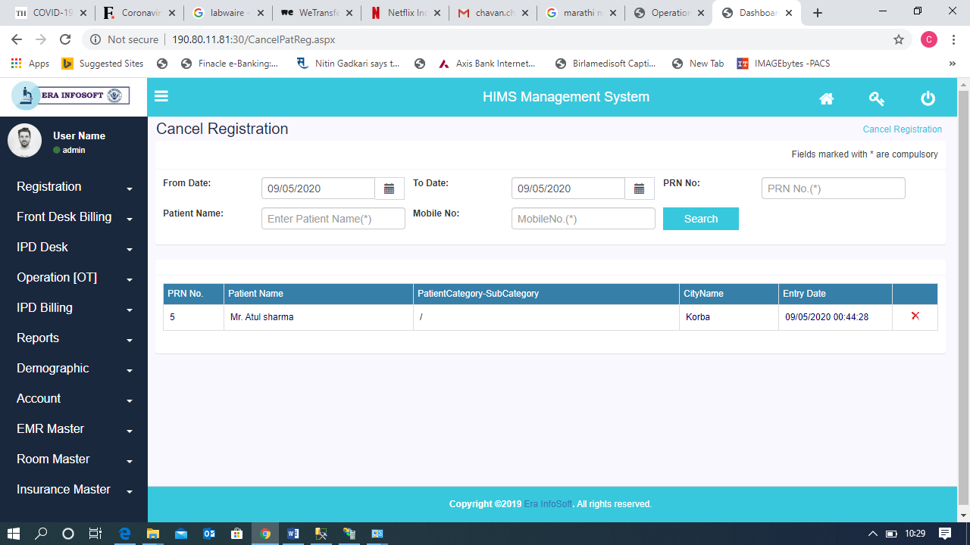
This is cancel Registration form Patient category Not showing in Grid .
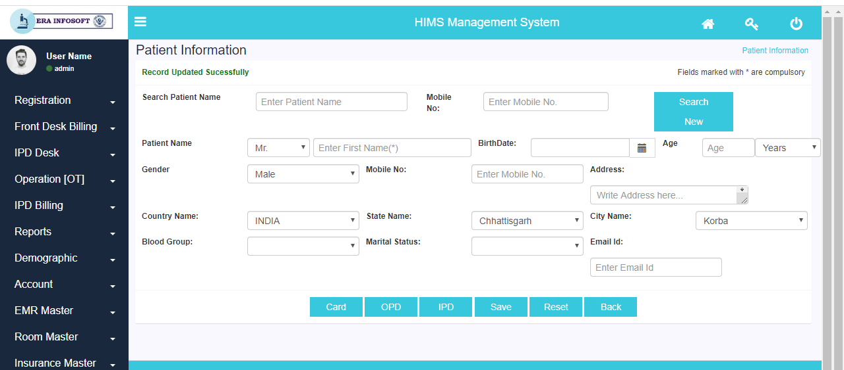
THIS is Main Registration Form when click on IPD Button following error message showing
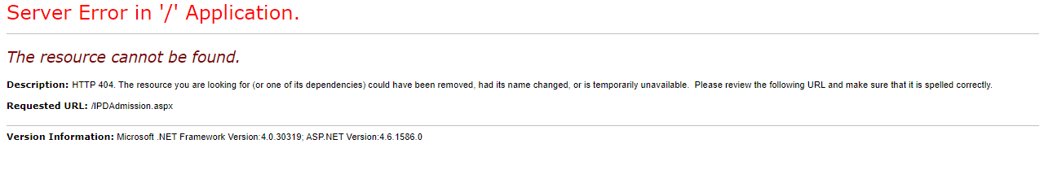

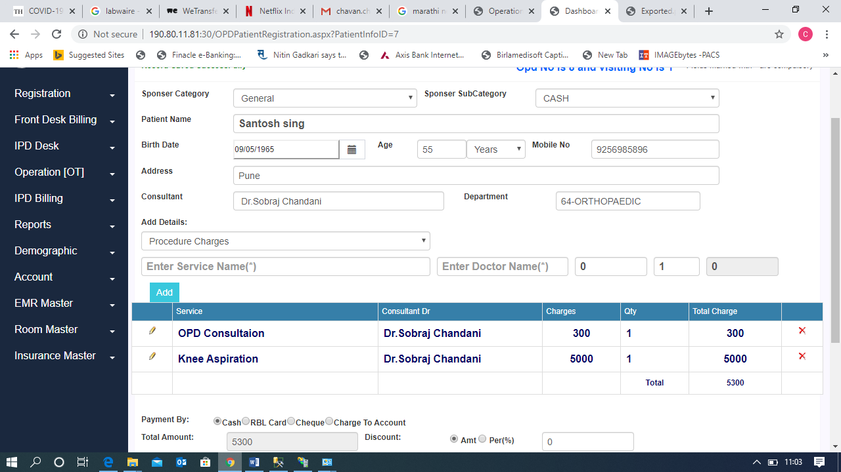
In Charges GRID field there is showing charges but its not reflecting on OPD Bill
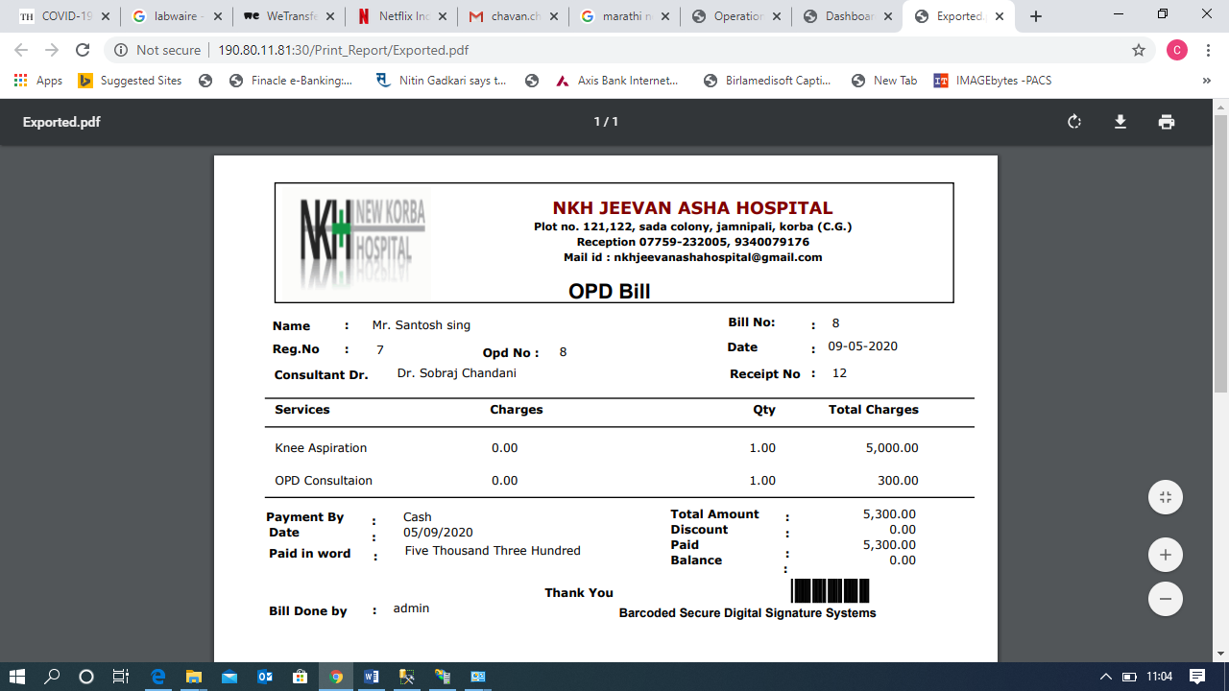
Charges Field display Zero charges.
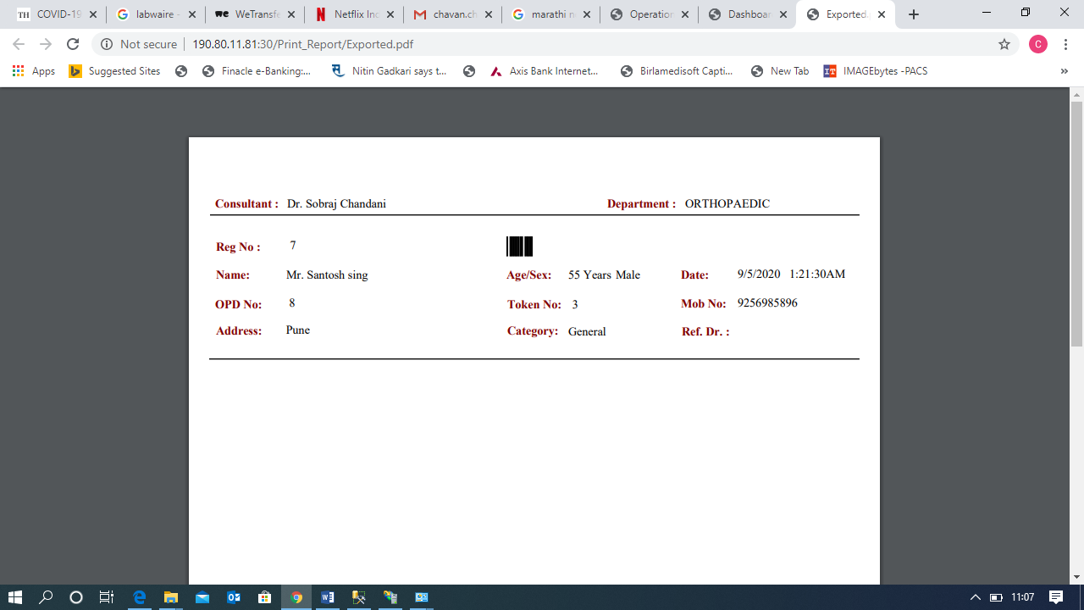
Need to add header (Hospital details like OPD Bill)
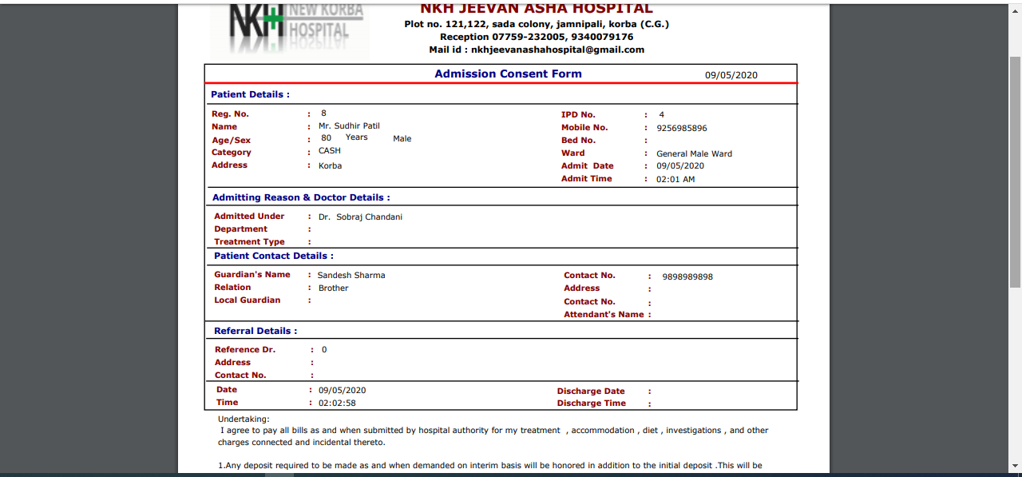
Admission front sheet dr Department field showing blank .
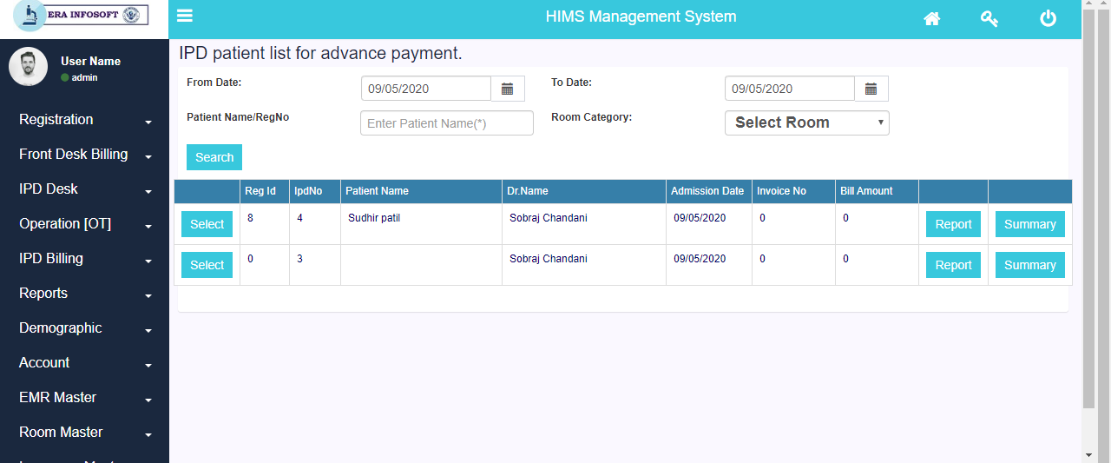
Patient details adding when I fill the admission form directly without patient registration. After save button clicking it should not be save details. The record is adding directly with IPD number in IPD Patient advance list add validation like without registration it should be not generate IPD number
When I select blank RegID . advance page going to open and its able to take advance money.
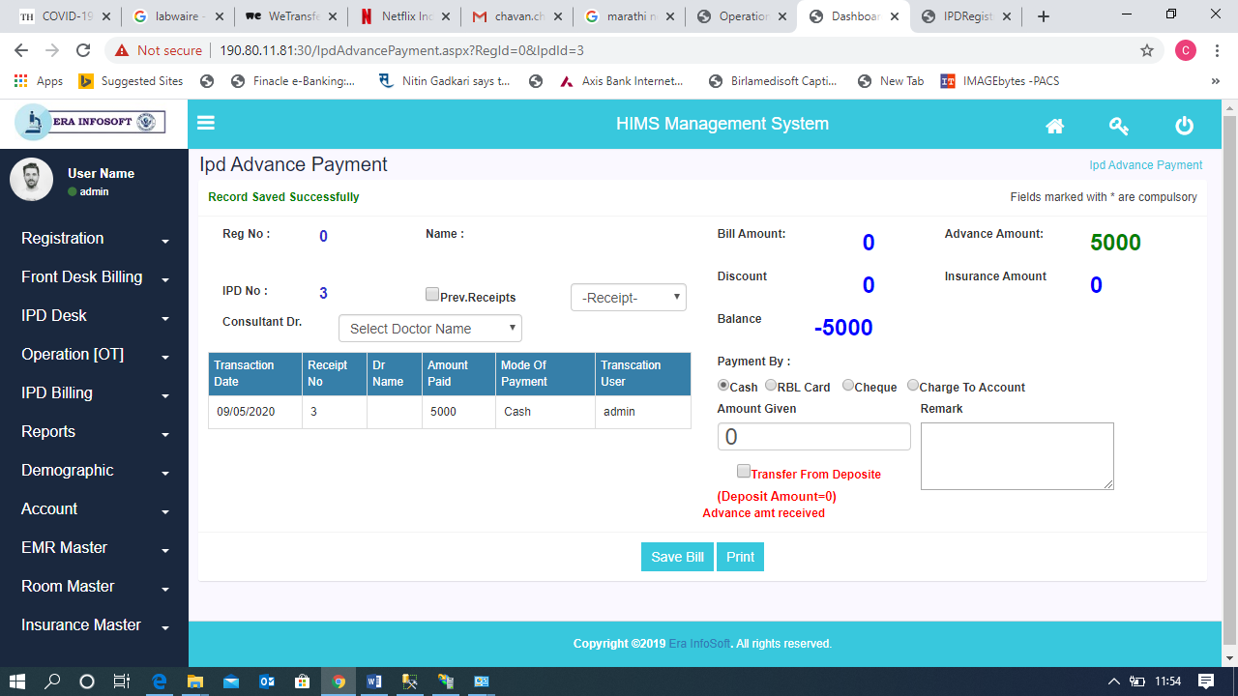
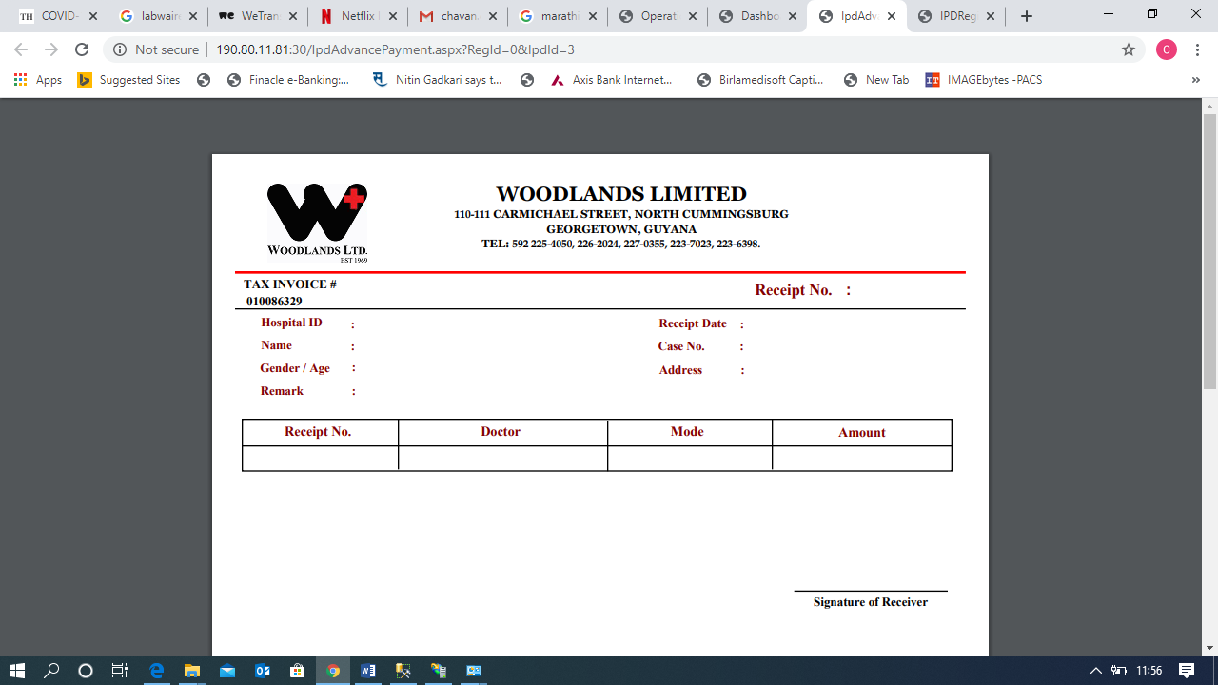

Blank Receipt

Vw_OPDBillServiceDetails
Vw_DrWiseIncomeReport

Vw_OPDBillServiceDetails

SP_InsertIPDBillTransaction
DiscountTypeMst
Sp_Vw_CurrentAdmittedPatient
Sp_CurrentAdmittedPatient

